Long Pasture

All Persons Trail Tour

This interpretive tour typically takes 45 minutes to one hour.

We invite you to use this printed booklet to enjoy the trail tour.

Tour information is currently available in these formats:

* You can borrow a copy of the printed booklet.
* You can download and print your own customized copy of this booklet from our website, in whatever font, size, and color combination you prefer.

In fall 2024, more resources will be available:

* Self-guided tour booklet in multiple formats, including large print and braille.
* A tactile trail map.
* An audio tour to download from our website to your own audio device. Or you can borrow a Victor Stream Reader audio player by contacting us in advance at 508-927-1200.

Please call ahead for information on trail conditions and to find out what items, materials, and equipment are available for loan.

We gratefully recognize the commitment and generosity of the donors and the accessibility consultants that have made this project possible.

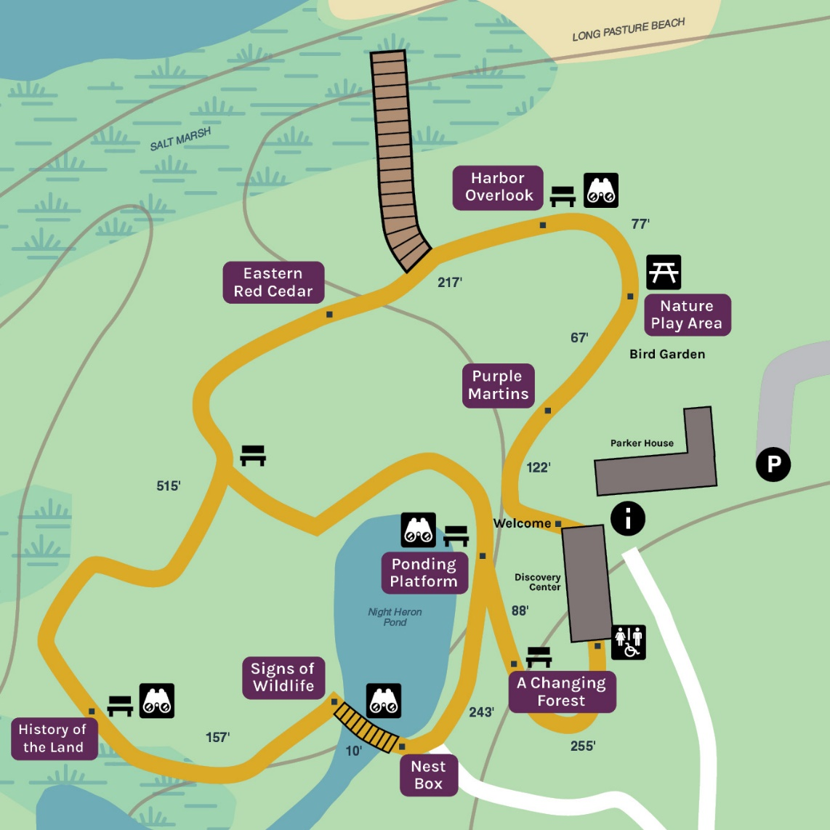

Welcome to the Long Pasture Wildlife Sanctuary All Persons Trail

This 1,900-foot universally accessible trail visits five habitat types including field, tidal flats, salt marsh, forest, and freshwater pond. The trail begins and ends at our Discovery Center and has looping sections that can be traveled in either direction. There are nine enrichment stops that expand upon the natural history of the sanctuary. You may experience the trail in your own way, or follow the interpretive tour, which is available as an audio recording and as a printed booklet in regular, large, or braille format. Resources including contact information for borrowing braille booklets and audio players can be found on our website.

This gradual sloping trail is surfaced with a compacted 3/8-inch crushed stone and includes a 50-foot boardwalk section and a 12x16-foot viewing platform. The trail is equipped with a navigational post-and-rope guiding system for all but the front lawn section of the trail. This interruption in the rope guide will be described when it occurs. This rope guide is within arm’s reach and is 32 inches above the ground. Two different kinds of beads are attached to the rope guide. A spherical bead indicates that an enrichment stop marker is within arm’s reach with the name of the stop in large print and braille. A cube-shaped bead indicates that a seating area is nearby. Six multi-use seating areas are spaced equally along the trail. It may take 45 minutes to one hour to complete the tour, depending on travel mode, pace, and resting time.

We hope you enjoy your time on this All Persons Trail. To learn more about Mass Audubon’s work, visit our website at **massaudubon.org/accessibility**.

Acknowledgment

Mass Audubon acknowledges that Long Pasture Wildlife Sanctuary is located on the traditional, contemporary, and unceded territories of the Wampanoag Peoples and the Mattachiest Tribe of Cummaquid. These lands were taken from the Indigenous people, creating a legacy of trauma that persists to this day. We acknowledge that Indigenous stewardship of the land we now call Massachusetts kept its ecological communities vibrant, strong, and interconnected for thousands of years, but far from being relics of the past, Indigenous peoples, including the 37,000 individuals who currently reside in Massachusetts, are still at the forefront of environmental protection, ecological stewardship, and climate mitigation. Mass Audubon deeply values the relationships that we have built with Indigenous people to date, and we recognize that there is much work still to be done. Acknowledging Indigenous sovereignty and the ongoing trauma of colonialism is only the first step—and an imperfect one at that. Mass Audubon is committed to the work of learning, listening, and evolving so that we may live in the right relationship with the land and the people who have been its rightful stewards for thousands of years. We know this work will take persistence and time.

*To continue on this tour, follow the gradually downward-sloping trail for another 122 feet to the next stop. Between April and August, you may hear the chirps of the Purple Martin colony. A stop marker and tactile display will be on the right.*

Purple Martins

During the spring and summer months, dozens of Purple Martins can be seen filling the sky at this location. Listen to the Martin’s distinctive chirps and rattles. These insectivorous birds are strong and graceful fliers, adapted to precise maneuvering for catching insect prey in flight. A martin decoy is on display. Purple Martins are colonial nesters, meaning they form large colonies of nesting pairs. Martins are also cavity nesters. Traditionally, these birds utilized natural cavities such as woodpecker holes, but thousands of years ago, people began making cavity nests out of dried hollow gourds. The birds adopted these new artificial nest sites and, with a declining availability of natural nest sites, soon became dependent on them. Today, plastic, wood, and aluminum housing is designed to meet the exacting needs of the Martins and those humans who want to attract them. Our Martin houses are made of plastic and hung on aluminum racks. To deter snake and raccoon predators, the gourds are hung 20 feet in the air. One of our gourds is displayed here for you to see or touch. In it are replica Martin eggs and typical nesting material used by Martins.

The arrival of our migrating Martins each spring is a rite of passage. These arrivals consist of an assortment of unrelated breeding birds and their young. Older birds that arrive first to the colony are known as scouts. By mid-May, the colony consists of four distinguishable classes: adult male, adult female, subadult male, and subadult female. After nestlings fledge, a juvenile class is added.

Up to eight eggs per nest are laid by mid-May. Incubation lasts 15-16 days. Once hatched, the young receive care from both parents until they fledge at 26-32 days. By late August, the colony begins to depart for South America.

Long Pasture’s colony has included as many as 24 pairs and fledged up to 90 birds during a breeding season.

*To continue, follow the level trail for another 67 feet to the next stop. A braille marker will be on your right. There you will find a picnic table-style seating area.*

Nature Play Area

Spending time outdoors is good for our minds and bodies.Sadly, children today spend less time outside than any other generation before them. We're here to change that. Nature play areas like this invite kids to connect with nature by encouraging self-directed, informal play. There are endless benefits to playing in the outdoors, including health and exercise, imagination and creativity, risk-taking and problem-solving, learning by exploration, and fun. When children are active in nature, they find connections to the natural world. These connections are critical to creating the next generation of nature heroes!

Here, kids can crawl through the hollow "stump tunnel," climb tall branches, and test their balance on our flexible balance beams and handmade seasaw.

It also features a one-of-a-kind musical pebble harp that creates entertainment with musical tones from pebbles cascading over metal strings. And burgeoning young artists can use the art easel for expressing themselves in new ways.

Enjoy our native bird garden while relaxing on our accessible picnic tables adjacent to the play area.

*To continue, follow the level trail for another 77 feet to the next stop. A braille marker and artifact display will be on your right. You will also find a seating area approximately 40 feet from the coastal berm. At this location, you may hear and smell the ocean.*

Harbor Overlook

You are in front of the 9,000-acre Barnstable Harbor Sandy Neck Ecosystem. At low tide, most of the harbor turns to tidal flats, exposing a myriad of shellfish and shorebirds. The largest salt marsh on Cape Cod rings the harbor. The salt marsh is a nursery to many shellfish, finfish, and shorebirds, providing protection from storms and absorbing pollutants. This is the most biodiverse habitat in North America. Sandy Neck Barrier Beach is a 3,300-year-old and 7-mile "arm” protruding into Cape Cod Bay. It provides wave protection to the leeward harbor, allowing the salt marsh to grow. The interior of the Neck surprises visitors with freshwater pools surrounded by pitch pine forests.

Horseshoe crabs have existed in practically unchanged form for more than 400 million years, and they are the same now as they were when living side by side with dinosaurs. In fact, horseshoe crabs are commonly referred to as "living fossils" because they are one of the most ancient creatures still living today. The species that currently calls Massachusetts home is the Atlantic Horseshoe Crab (Limulus polyphemus).

Horseshoe crabs have excellent eyesight thanks to five pairs of eyes and can see just as well at night as they can during the day. Horseshoe crabs also have a wide field of vision, which means they can see their surroundings in all directions—in front, behind, both sides, and above! Photoreceptors on their tails are sensitive to circadian rhythms, enabling horseshoe crabs to "tell time” by tracking the hours of daylight.

In spring, adult crabs make their way onto beaches during full moons to mate. Males use their front "boxer” claws (shaped like boxing gloves) to physically attach themselves to the larger female crabs, and they will stay attached for an entire tide cycle—or longer. The females then dig shallow nests about 5"-10" deep in the sand where they lay two to five clusters that each consist of anywhere from 2,000-4,000 eggs. Over the course of a season, a single female horseshoe crab may lay up to 80,000 eggs.

Development takes two weeks before the crabs hatch as tailless trilobite larvae. Once hatched, larvae will molt six more times in the first year while slowly moving out to deeper water.

Unfortunately, the Commonwealth's population of these incredible marine animals is depleted and is facing increasing threats. In Massachusetts, horseshoe crabs are harvested to be used as bait for the whelk fishery. Additionally, their blood is the only source of a chemical that's used to test medical devices and injectable drugs for toxins. When harvested for medical use, the crabs are caught, bled, and then returned to the water. Unfortunately, up to 30% of horseshoe crabs ultimately die following this bleeding process. Increased harvesting of these fascinating animals threatens their population.

Mass Audubon has been conducting long-term surveys of spawning horseshoe crabs on Cape Cod and Martha's Vineyard since 2001, including here at Long Pasture. The data collected during these surveys is submitted to the Massachusetts Division of Marine Fisheries, which uses the information to determine the best conservation and management practices for Massachusetts horseshoe crabs and the horseshoe crab fishery.

During the summer months, you may encounter many on the tidal flats. Handling live horseshoe crabs can harm them, but the crabs’ washed-ashore sheds, or “casts,” which represent all of the crabs’ anatomical features, can be safely examined. You can see and touch the replica in front of you, and we have casts in the Discovery Center for closer examination.

The sea level in Barnstable Harbor has risen 11 inches since 1922 and is threatening both natural and cultural communities. Sea level rise markers located at the boardwalk in front of you show the current high tide, and the projected high tides by 2030 and 2050. By 2050, Barnstable Harbor could see between 50 and 70 days of high tide flooding every year. This so-called “sunny day flooding” will impact dwellings, roads, and infrastructure surrounding Barnstable Harbor, as well as the Barnstable Great Marsh in front of you.

Mass Audubon is mobilizing to fight climate change and is leading the way in helping the Barnstable Great Marsh withstand the impacts of sea level rise. With the help of our partners, we are planning a comprehensive salt marsh restoration project that will dismantle old farming infrastructure embedded in the marsh, restore natural tide flow, and build marsh resiliency.

*To reach the next stop, follow the level trail. A rope guide will begin 130 feet on the right and guide you to the next stop 217 feet away. A spherical bead will mark your arrival. A braille marker and artifact display will be on your right. Along the way, the trail width will decrease from 6 feet to 5 feet. This trail section travels closest to the ocean of any section.*

Eastern Red Cedar

Welcome to this hauntingly beautiful little stand of Eastern Red Cedar. Red Cedar is an early pioneer tree that can quickly take over sunny, dry spots such as old, abandoned fields. During the 19th century, agricultural land was cleared for growing crops, grazing animals, or producing hay. Once the farmers left, pioneer plants like cedar colonized. Trees can grow to 50 feet in height but eventually will be shaded out by the growth of other pines and hardwood trees such as white pine and red oak.

Eastern Red Cedar berries are a preferred food source of several bird species, such as thrushes, American Robins, and Cedar Waxwings, all of which help disperse seeds. The cones and wood of the tree have a strong pungent smell that is part of the tree’s defense against insects.

Cape Cod hosts another species of cedar, the Atlantic White Cedar. This wetland species grows along the Atlantic coastal plain in wetlands including swamps, bogs, and marshes. It thrives in acidic soils. A rare white cedar stand can be found at our Skunknett River Wildlife Sanctuary.

A slice of Eastern Red Cedar, also called a “tree cookie,” is displayed here for you to scratch and sniff.

*To reach the next stop, follow the level trail with a rope guide on the right side for another 515 feet until you reach both a cube and spherical bead. A braille marker and artifact display will be on your right. You will also find a seating area on the left at that stop. Halfway to the next stop there will be an intersection where you will have the option to veer off the trail onto a shortcut back to the Discovery Center. Please note, this 80-foot section of trail does not have a post-and-rope guide in its entirety*.

History of the Land

Cape Cod is a very young landscape in the scale of geological time. The Laurentide ice sheet retreated from Cape Cod 15,000 years ago during the last glacial period known as the Wisconsin Glaciation. As the climate warmed at the end of the Ice Age, the ice sheet melted and retreated northward, shaping the landscape of Cape Cod and leaving behind such features as kettle holes, moraines, and outwash plains.

The gentle rolling landscape at Long Pasture is characteristic of the moraines found on the north side of Cape Cod. The glacier deposited till, which is composed of rock fragments, ranging from clay to boulders. A slab of glacial rock is displayed here for you to touch and see. The wetlands, like the one in front of you, were created during the Long Pasture All Persons Trail Tour retreat of the glacier. Many have been altered by human activities, like this one, for irrigation and fishing.

The local Native Americans on Cape Cod, called the Wampanoag, had a very different approach to land use than the English settlers. Hunting and fishing lands were divided among the island's four sachem tribes and were used and lived on seasonally and often cooperatively. The land below you was once the home of the Mattachiest tribe of Cummaquid.

Settlers stripped the land of its forests to make farmland, graze sheep, and build homes. While destructive to forest-dwelling species, the resulting landscape accommodated sunny grassland-loving species that are rare today. Plant species include little bluestem, butterfly weed, wild indigo, low bush blueberry, and bearberry. Grassland birds such as grasshopper sparrows, eastern meadowlarks, American kestrels, northern harriers, short-eared owls, and barn owls are all uncommon or declining on Cape Cod today.

Long Pasture was utilized as a farm until the early 1900s. Wetlands here were drained, ditched, or filled to maximize farming land. The wetland in front of you was altered by damming to accommodate stocking of fish and to irrigate crops. Mass Audubon has since naturalized this pond and restored many others to support a wide diversity of wildlife. Our goal is to promote biodiversity and manage the property for early successional habitat for the species of plants and animals that utilize it. How might you help support diversity in your own way?

We invite you to spend a moment in quiet reflection to honor the history of this land and the many people who have called it home.

*You are approximately halfway through the trail now. To reach the next stop, follow the level trail with the rope guide on the right side for another 157 feet until you reach the next spherical bead. At that point, the surfacing of the trail will change from gravel to a railed boardwalk. A braille marker and artifact display will be on the railing to your left. This section of trail will guide you along the edge of Night Heron Pond and stop at the pond bridge*.

Signs of Wildlife

A game camera set up at this location documented nine different mammal species over a 7-day period, including coyote, fox, raccoon, possum, muskrat, rabbit, squirrel, otter, and short-tailed weasel.

Understanding the signs animals leave behind allows you to document them without seeing them. The artifacts you see displayed in front of you are examples of such signs, such as claw marks on a tree, scat, or tracks left in the mud. See if you can recognize these signs in your neighborhood.

Most people would not be surprised at all to see a Chickadee, gray squirrel, or cottontail rabbit in their neighborhood or near their home. But many people are surprised to encounter coyotes, river otters, barred owls, or fishers. These animals are rapidly adapting to suburban and sometimes even urban environments. While many species that have specialized lifestyles are uncommon and living away from us, there is a growing number of generalists that are taking up residence in more human neighborhoods. The Eastern coyote, once thought to prey exclusively on mice and hares, now will happily scavenge a hot dog on the beach or a watermelon in a garden, or dumpster dive for leftovers from your kitchen. Barred Owls, once thought to be inhabitants of deciduous forests, are now nesting along tree-lined streets.

These suburban animals are crepuscular, meaning they are active at dawn or dusk. Early risers or sunset strollers can readily witness their normal behaviors without strolling far from home. A game camera set up near your house can photograph a surprisingly large number of species.

North American River Otters are one of Cape Cod’s five species of weasel, along with fisher, ermine, short-tailed weasel, and mink. They have long, slender bodies with short legs and webbed feet. Their thick tails taper to a point, making them efficient underwater hunters. They have a dark brown, water-repellent coat, a lighter-colored belly, and a silver-gray throat. Otters frequent Night Heron Pond for food including fish, turtles, frogs, and crustaceans, and utilize the woody protected banks for den sites. Otters are the most aquatic of the weasels and travel by water, but in environments like Cape Cod with little fresh water, they have adapted to cruising the undulating coastline and bays. River otters are crepuscular, yet they have been viewed at Night Heron Pond in the early morning hours in March and April, when they are paired up looking for den sites. An otter pair with pups was observed here in 2015. At Long Pasture in winter, one otter was tracked by following its footprints and slide marks from Barnstable Harbor along the All Persons Trail and into Night Heron Pond. Observations have also been made at Long Pasture’s beach, on our trails, and on Bone Hill Road. Look out while driving! It's hard to see otters, but you may detect otter scat. Their scat can be seen around Night Heron Pond and especially next to this boardwalk. Look for fish scales and bones. Sometimes the scat is reddish in color. This is the result of a diet of crayfish.

If you have questions about living with wildlife, please see our Visitor Services staff or check out our website.

*To reach the next stop, follow the boardwalk 10 feet to the end. Boardwalk railings substitute for the guiding rope. A braille marker and tactile display will be on the railing to your right*.

Nest Box

What makes a good home is in the eye of the beholder, and for wild animals, sometimes the ideal home is shared among different species. The nest box above you on this poplar tree has been the home to Wood Ducks, saw-whet owls, and screech-owls.

Screech-owls vocalize in a mournful horse-like whinny that is tremulous and descending in pitch, and also a tremulous monotone given on one pitch. Eastern Screech-owls are seen and heard throughout Long Pasture.

Directly above this sign is a nest box for you to explore. It includes three replicas: a screech-owl egg, a half-size replica of a screech-owl and an owl talon. Notice the shape of the owl, the sharpness of the talon, and the size of the egg.

Screech-owls are formidable hunters, and they help control the populations of small animals such as rodents. Their eyes are fixed in place, and their necks can turn 270 degrees, enabling them to more easily focus on their prey. Their enhanced eyesight and keen hearing enable them to hunt successfully, even in the dark. Owl feathers have small “fringes” on the edge that help minimize sound. Their wings are also larger than their bodies, allowing them to fly at slower speeds, further reducing the amount of sound they produce. Owls are efficient stealth hunters. Even an owl’s egg shape is an adaptation for survival. Many owls nest in tree cavities, so the round shape of their eggs ensures that they can safely move if accidentally kicked or jostled. Oblong-shaped eggs, like those of many songbirds, belong to eggs found within nests located on tree branches. The oblong shape of songbird eggs prevents them from rolling out of the nest.

Birds have unique requirements for a suitable nest box. They require the nest box opening to be a certain size, and some species have height orientation or material requirements. Building nest boxes is a great way to create habitat for wild animals. Some local populations of Osprey and Purple Martins have become dependent on the artificial nests we have made for them.

*To reach the next stop, follow the level trail and rope guide on the left for another 243 feet until you reach both a cube and spherical bead. A braille marker will be on your left. You will also find a pond platform, artifacts on the platform railing, and seating area at that stop. This section of trail places you in close proximity to Night Heron Pond, where glimpses of the pond can be seen through the vegetation. The Discovery Center will be on the hill to your right*.

Ponding Platform

If you approach the pond quietly, you may observe turtles sunning atop logs. Listen for turtles or frogs as they plop into the water if they are startled. This pond, known as Night Heron Pond, is habitat for many aquatic creatures including painted turtles, green frogs, and bull frogs, and invertebrates such as crayfish and dragonfly nymphs. The ponding platform has railings on the left, center and right. Mounted on the left railing is a dragonfly life cycle model. Birds that frequent the pond and its edges include Black-crowned Night Herons, Green Herons, Belted Kingfishers, and Mallards.

Snapping turtles also call Night Heron Pond home. Mounted on the center railing is a snapping turtle hatchling model. Look and feel for some of the features that identify these impressive reptiles—the three rows of ridges along the upper shell, the deeply toothed rear margin and the long, spiky tail.

Mounted on the center railing is a frog tadpole development model, representing the stages of development a tadpole goes through from egg to metamorphosed frog.

This pond was formerly a shallow wetland prior to being dredged and dammed in 1951 by the former owner of the property, Sherman Parker. Mr. Parker stocked the pond with bass, established aquatic vegetation to attract waterfowl, and pumped the pond to irrigate vegetable crops in what is now the parking field.

*To reach the next stop, cross the trail and follow the rope guide on the left gradually up for another 88 feet until you reach both a cube and spherical bead. A braille marker and tactile display will be on the left. You will also find a seating area at this stop on the left. Alternatively, you can take a left from the platform and follow the 80-foot connector trail along the pond back to the cedar stand and overlook stops. A bench will be located 80 feet along the trail in this direction*.

A Changing Forest

In 2024, the section of path before you now was cleared of invasive species of plants and re-established with native species of grasses, wildflowers, trees, and shrubs to help support native pollinator species. The life cycle of a rare and important pollinator, the monarch butterfly, is represented before you. Cape Cod has undergone a dramatic change in its forest cover over the last 300 years. Prior to European colonists, the Wampanoag people managed the forest holistically and sustainably for food and medicine, shelter, tools, and spiritual practices. Early colonists managed the forest to meet their needs for timber and lumber, agriculture, and charcoal production for heating coke and smelting iron ore. The forests were also used for hunting and trapping. By 1800, 70% of Cape Cod forests had been transformed into farms, and one could see ocean views from nearly every hilltop. By the mid-1900s, forests were making a comeback as the Cape’s economy shifted from farming to tourism and service. Today, approximately 60% of the Cape’s land is forested.

Forest changes at Long Pasture would have been very similar to that of Cape Cod’s. In 1950, prior owner Sherman Parker aimed to create wildlife habitat by planting some 1,000 trees on 44 acres of previously farmed land. Many of these trees can be seen around you at this stop. The three tall conifers clustered on the hill above you are European tamarack. An English holly sits just beyond them, and in the forest beyond are several mature Chinese Chestnuts. Each tree represents the growth of its species since 1950.

Sherman Parker and others of his time were not necessarily concerned with the concept of wildlife restoration using native species. Today, Mass Audubon is actively managing these and other forests in Massachusetts for biological diversity and for rare species. For more information on the species of native plants we use to attract wildlife, please ask our Visitor Services staff.

*This is the last stop. To finish the tour, follow the rope guide on the left for 255 feet until you reach the Discovery Center. Along the way you will encounter the steepest section of the trail, a 10% grade traveling 30 feet, and a 12% grade traveling 10 feet. You will also travel over three shallow drainage bumps designed to channel water off this steep section of trail. Use caution*.

**Thank you for visiting this All Persons Trail.**

We hope you have enjoyed your visit to Long Pasture’s All Persons Trail. Please visit again in other seasons, and also visit some of Mass Audubon’s other All Persons Trails. For more information on our All Persons Trails, or to provide feedback about your visit to this trail, please visit [**massaudubon.org/accessibility**](https://massaudubon365-my.sharepoint.com/personal/kbates_massaudubon_net/Documents/APT%20signs/LP/www.massaudubon.org/accessibility).

Please return any trail materials you borrowed. Thank you.