Wachusett Meadow
All Persons Trail Tour

This interpretive tour typically takes 45 minutes to one hour.

We invite you to use this printed booklet to enjoy the trail tour. When you are finished, please return the booklet to the Visitor Center so it can be available for others to borrow.

This tour information is available in several formats:
- You can borrow a copy of the booklet printed in braille, with a tactile map.
- You can download and print your own copy of this booklet from our website, in whatever font, size, and color combination you prefer.
- You can take the tour using an audio recording. The audio files are available to download from our website to your own audio device. Or, you can borrow a Victor Stream Reader audio player by contacting us in advance at 978-464-2712.

There are several items available for you to borrow: trail wheelchair, rollator walker, seat cane, walking stick, binoculars, hands-free optics, audio player, field guides, and family-friendly education and activity materials.

We gratefully recognize the commitment and generosity of the donors and the accessibility consultants that have made this project possible. They are listed on the last page.
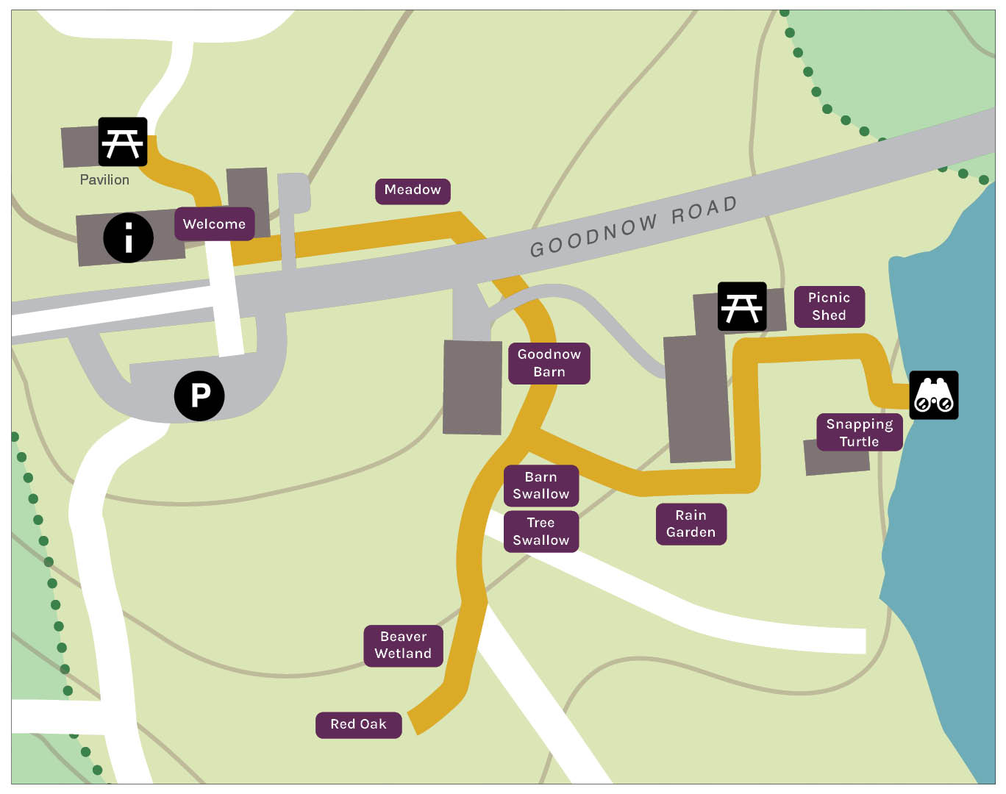

Welcome
Welcome to the All Persons Trail at Wachusett Meadow Wildlife Sanctuary. This trail is designed to provide a self-guided, universally accessible, and sensory experience that connects people of all ages and abilities to a variety of ecosystems and some of the most interesting and peaceful destinations on this property. Please take only pictures and leave only footprints. Enjoy your visit.
The All Persons Trail begins here at the Visitor Center and then traverses to its destinations. It is an out and back trail, not a loop. The round-trip distance in its entirety is 2170 feet or four tenths of a mile long, and a total of eight interpretive stops feature the history and natural history of this wildlife sanctuary. The full tour typically takes an hour to complete. The trail can loosely be thought to be “Y” shaped with the initial section 342 feet in length, and then branching to a 338-foot leg and a 405-foot leg. Seating along the way includes a garden swing, benches, flat boulders, rocking and stationary chairs, and accessible picnic tables. Note that the Pavilion, located directly behind the Visitor Center, is also an accessible picnic space. Trail surfacing varies and includes sections of pavement, brick path, crushed gravel, and grass paving. Grass paving remains firm and level in all conditions and the trail is maintained with regular mowing, but it is not cleared of snow in winter. Note that taller meadow vegetation may be growing along the edges, occasionally bending in toward the treadway.

If you need assistance or wish to access the Visitor Information desk in the Office, enter the open breezeway located to the left of the Trailhead. The door on the left leads to the Office and gift shop. The door on the right leads to the restrooms and the Program Room. Each of the restrooms, men’s and women’s, has two stalls, one of which is ADA compliant.
Facing the orientation panel, the trail begins immediately to the right on a brick walkway that extends for 49ft. At the end of the walkway the trail crosses an asphalt driveway, which is the entrance to a small staff parking lot. Beyond the driveway the treadway transitions to grass paving for 88ft to the Meadow Stop. The Meadow sign is mounted on a section of split rail fence on the left side of the trail.
There is a garden swing and multi-use seating area on the right-hand side of the trail if you wish to take some time enjoying this meadow. You may have shade and the company of birds from the red maple tree just beyond the swing.

Meadow
Meadows are dynamic communities that can include a tremendous variety of plants and animals. Beyond the split rail fence, this 10-acre meadow extends expansively, open to sunlight, wind, sounds, and scents.
Bird activity is nearly always present, varying by season. Bobolinks nest in the tall grasses and males are particularly conspicuous in their distinctive buff, black, and white breeding plumage, and by the burst of their bubbly, meandering song in spring and early summer. Look and listen for the loud scolding of blue jays, the “meow” of gray catbirds, the raspy cry of red-tailed hawks, and the “po-ta-to-chip” sounding flight song of goldfinches. An abundance of butterflies and dragonflies may dart or flit above the vegetation, and the steady pulse of sound from crickets and katydids builds as summer advances.
Grasses and other young meadow plants are deep emerald green in spring, but by summer and fall there is a mosaic of color and texture including ferns, goldenrods, asters, and milkweed. Milkweed has showy pink flower clusters that are highly fragrant; when their fruit pods dry and split open, many dozens of seeds are revealed, each equipped with a fluffy white “parachute” that allows for wind dispersal. On a dry breezy day, they may drift by like snowflakes.
The trail continues another 25ft to the asphalt road crossing. On the left-hand side of the trail, the split rail fence terminates at a head high vertical granite pillar that stands a few feet from the road edge. The trail crosses at an angle bearing left to a 6-foot-wide gap in a stone wall. Animal tracks are painted in the roadway to indicate the route.
Past the wall gap, grass paving continues for 36ft and then crosses a crushed gravel driveway. The driveway provides occasional vehicle access to the barns that stand both left and right of the trail. The Goodnow Barn Stop and location sign is on the right, just beyond where the trail transitions back to grass paving.

Goodnow Barn
The Goodnow Barn is named for the family that constructed it in the mid-1800’s after they settled here. It is a sturdy and time-honored post and beam structure that throughout its long history has sheltered a variety of livestock and stored hay. That tradition continues today as the barn houses the small flock of sheep that are resident at Wachusett Meadow. They may be present in the fenced paddock that begins where you are, and runs parallel as the trail continues – if so, you may have seen or heard the sheep well ahead as you approached! Or perhaps you noticed the sweet scent of freshly cut hay if the loft has recently been stocked with winter feed. The raising of sheep is a tangible connection to the farm history and buildings on this property. With the use of portable fencing, grazing activity is rotated through the growing season to create a patchwork of vegetation heights, ages, and composition, which provides a variety of cover for small mammals, birds, snakes, and insects. The large gambrel barn more distantly to the left intersects along other sections of this trail.
The trail continues for 62ft to the Swallows Stop. The grade is gently sloped downward and metal handrails run along both sides. Signage and an interpretive feature are mounted on a section of split rail fence just beyond where the handrails end and the trail flattens.

Swallows
During the spring and summer months, dozens of swallows may fill the sky from this vantage. Swallows are strong and graceful flyers, adapted to precise maneuvering for catching insect prey in flight. The signs and display found at this stop identify the two species occurring here, including the silhouettes of each in flight – tree swallow on the left and barn swallow on the right (both birds face left). Look and feel for the long, pointed wings of both species, and the slender, deeply forked tail of the barn swallow, compared to shallow, wedged tail of the tree swallow. Tail shape often allows quick identification even at a distance.
The reason for all the activity in this location is the nesting opportunities for both species. Barn swallows build mud nests that are adhered to the timbers on the ground floor of Goodnow Barn, now just behind you and to the right. Look and listen for the frequent flights of the adult birds in and out of the barn, narrated by lively chips and twitters. Tree swallows nest in small tree cavities, but will readily take advantage of provided structures. Facing the signs, there are about a dozen nest boxes a short distance directly ahead. You may hear similar chatter from the parent birds around these boxes, particularly a sharp, high-pitched chip as they swoop toward any potential threat around their nests.
Eastern Bluebirds also use these boxes, but they are more likely to be observed perched or in short flights to the ground searching for the prey to be found there. Bluebirds can often be seen or heard well beyond the breeding season – perhaps landing or fluttering around the fence posts or vegetation. Even in winter, small flocks sporadically come and go.

This location is the junction between two additional sections of the All Persons Trail. The audio tour and the printed and tactile booklets describe the trail along the right leg first, but you may choose either direction.
Continuing to the right, the trail traverses an open meadow landscape for 200ft to the Beaver Wetlands Stop. Midway, a trail intersects on the left leading to an observation blind. Please note that this spur trail on the left is not an ADA-compliant route and is not described in the All Persons Trail materials. The Stop is marked by two side-by-side sign posts on the left-hand side of the trail; one indicating the location and one for an interpretive feature. This Stop also occurs at a trail intersection. The All Persons Trail continues to the right, and South Meadow Trail bears left. South Meadow Trail is not an ADA-compliant route and is not described in the All Persons Trail materials.

Beaver Wetlands
Facing the sign posts, the high edge of this meadow is a short distance ahead before the landscape slopes sharply toward an 80-acre beaver wetland. The water bodies that beavers create not only provide the conditions needed for their own survival, they also help to sustain many other species. This is particularly true because these communities typically are ever-changing. Over decades, this wetland has transitioned from red maple swamp, to pond, to marsh, and has hosted different plants and animals at each progression.
A primary beaver activity to acquire part of their food resources and building materials for dams and lodges is the felling of trees. Beavers have sharp, chisel-like incisors (top and bottom front teeth) that can remove enough chunks of wood near the base of the tree that it eventually snaps and falls by wind or gravity. The handiwork of some local beavers is displayed on the post to the right. Look and feel for the ridged incisor marks where wood was cut and pulled away, and the brittle point where the tree broke and fell. Beavers often cut large trees by removing wood in a ring all around the trunk. Small trees may be felled by that method, or by working from just one side and cutting across the trunk, potentially in mere minutes.
The trail continues 128ft to the Red Oak Stop. There is a bench, and a post with the location sign on the right, where the trail widens to a small seating and observation area.

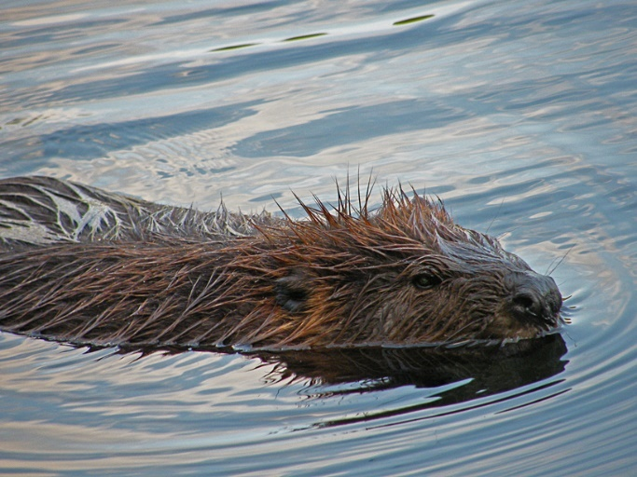

Red Oak
The grand tree in front of you is a northern red oak, over 14ft in circumference with a crown spread over 70ft. Forest oaks need to grow tall and straight in order to reach the sun among a crowded canopy, but this tree demonstrates the intricate, widespread architecture resulting from its long history of growth in an open landscape.
The bench and the adjacent multi-use seating area beneath this tree provide a remarkably peaceful and interesting place to spend a little time – or a lot of time! Most of the year, there is morning sun and cool shade by day. In the wind, the leaves rustling all at once creates a rush of movement and sound, replaced by the clatter of branches in winter. A variety of different ecological communities and associated wildlife are all around. The vast meadow is immediately adjacent, sometimes active, sometimes still. Woodlands beyond and to the right are home to many animals that utilize the cover of trees as well as the open fields, like red fox, white-tailed deer, and great horned owls. In spring, the trills of gray tree frogs and the American toads may drift up from the wetland, or large raucous flocks of red-winged blackbirds may be seen or heard in migration. A short distance to the left, a line of massive shagbark hickories stands alongside an old stone wall. The trees and the wall itself support wildlife that is traveling, resting, perching, perusing, and foraging. And finally, the old red oak is nearly a community unto itself, associated with all kinds of other organisms, from fungi at its root tips to birds on its branch tips, and everything in between.
The Red Oak Stop is the end point of this leg of the trail. Return by the same route to the trail intersection at the Swallows Stop. Bear left along the sheep paddock to retrace the trail back to the Visitor Center. To complete the trail along its final leg, continue forward/slight right for 90ft to Rain Garden Stop. Signage is on two side by side posts on the right, and includes a location sign and an interpretive sign. The information on the interpretive sign is repeated in the trail materials and the audio tour.

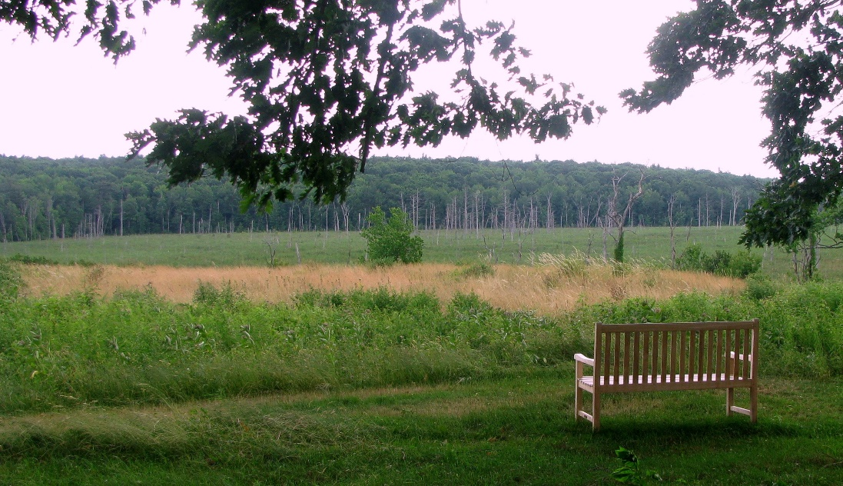

Rain Garden
Stormwater runoff is a major source of water pollution. When heavy rains saturate roads and lawns, the runoff carries silt, sediment, fertilizers, and toxins into local waterways. A rain garden can help capture the runoff, hold it, filter it, and allow it to slowly infiltrate into the ground. This is an ecologically sound way to recharge aquifers and reduce the amounts of pollutants entering storm drains or flowing directly into rivers and streams.
Rain gardens are designed with a shallow basin and filled with soils that allow infiltration. The gardens are populated with plants that can tolerate both drought and flood conditions, with deep roots to trap sediment. Rain gardens are useful anywhere runoff commonly occurs from roofs, roads, parking lots, and saturated lawns and yards.
Here, roof runoff from the adjacent barn is collected into a dripline trench that empties into this garden, helping to protect the water quality of Wildlife Pond and South Wachusett Brook, which is a tributary of the Wachusett Reservoir. Additionally, our rain garden is planted with a wide variety of hardy plants that are a valuable resource to pollinators, birds, and other wildlife.
In addition to its conservation value, this garden is a wonderful space for people to enjoy. It is lovely, and colorful, and fragrant throughout the season, and it hums with the activity and sounds of butterflies, bees, crickets, and the buzzy wing-whir of hummingbirds.
Just beyond this stop is a stone patio that widens to an observation area to the right. It is directly alongside the gable end of a former dairy barn on the left. Seating includes stationary chairs and adjacent space for wheelchairs, strollers, or other mobility devices, and large, flat boulders along the edges. The patio overlooks a seasonally changing landscape to the south, including Wildlife Pond towards the left, and bordering meadows and woodlands.
Beyond the patio, the treadway transitions back to grass paving and arcs sharply to the left before continuing for 90ft to the Picnic Shed Stop. The location sign is on a post to the left of the ramp entrance into the shed.

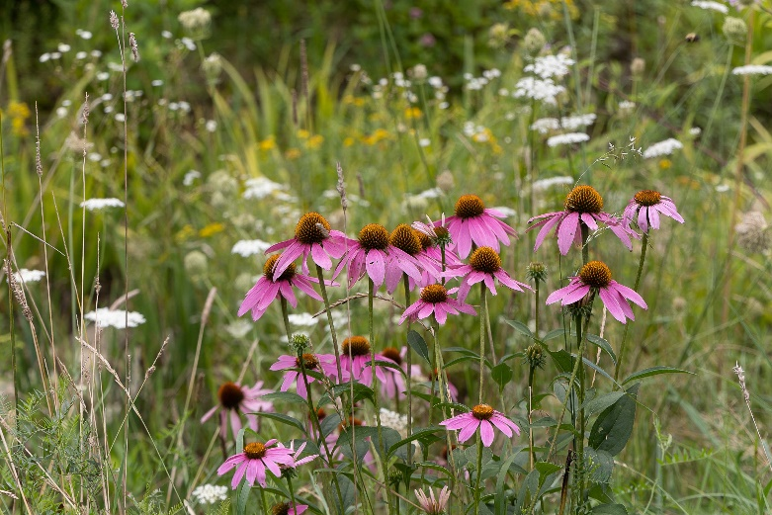

Picnic Shed
The Picnic Shed occupies half of a building that once served as the bullpen when this was a working farm. The other half has since been converted to a secondary sheep stall, and you may have the company of the flock if they are fenced here for the day. In the late 1920’s, after the Crocker family had become owners of this property, they built this complex of barns to support their prize-winning herd of milking shorthorn cattle. Looking out from the Shed, the large gambrel cow barn is perpendicular to the right, and a small barn used for manure storage is ahead. No longer present, twin silos and a milk house stood on the opposite side of these buildings. This would have been a busy part of the farm back then, with stanchions filling the space before you. Perhaps you can imagine the sights and sounds of the cows moving about, the heavy rolling barn doors, and the clanging of fences or milk pails.
Today, the Picnic Shed is a serene rest stop; a small meadow has reclaimed the barnyard, and Wildlife Pond is to the left. Seating includes two rocking chairs, adjacent multi-use space, and two ADA style picnic tables.
Heading left out of the Shed, the trail proceeds on a slight downward slope for 72ft. It then flattens and turns directly to the right and continues 39ft to the Snapping Turtle Stop. The location sign is on a post on the left, and a tactile sculpture of a snapping turtle is installed on an adjacent boulder. Just beyond the Stop, the trail widens to a seating area and observation space, with a bench directly forward.

Snapping Turtle
A life-size sculpture of an adult snapping turtle sits atop the boulder at this stop. Snappers are among the diverse community of species at home in Wildlife Pond, now directly ahead. Look and feel for some of the features that identify these impressive reptiles – the three rows of ridges along the upper shell and the deeply toothed rear margin, the long, spiky tail, and the large size, well beyond that of other inland turtles. The aggressive reputation of snapping turtles is often related to seeing them on land, where their vulnerability away from the water can make them defensive. Maybe you will be lucky enough though, to encounter one at ease and in its element here in this pond, surfacing among the lily pads, or burrowing into the mud, or drifting by in the shallows. There is a plaque on the boulder recognizing Bruce and Marcia Dean for the donation of this sculpture and Rosalind Sturges Waters for its creation.
Wildlife Pond is a hub of activity and always worth taking some time to look and listen, perhaps for a great blue heron stalking along the edges, a rumbling bullfrog chorus, a moose emerging from the forest to cool off, a busy congregation of whirligig beetles, the sudden plunge of a belted kingfisher, a river otter rolling in play, or the deep splash from a beaver tail.
Immediately to the right and ahead of the boulder, there is a gangway leading to a floating observation pier. The gangway is 25ft in length and is handrailed where it is raised. The treadway is wood decking and then aluminum. Please note especially that there is a short ramp between the gangway and the floating pier. The ramp is treaded for traction but all visitors should use care when entering and exiting. The pier is wood decking 10ft width by 14ft length; it is curbed but not handrailed.
The Snapping Turtle Stop is the end point of this leg of the trail. Return by the same route to the trail intersection at the Swallows Stop. Bear right along the sheep paddock to retrace the trail back to the Visitor Center.
Please stop by the Visitor Center to return any trail materials you borrowed.
We hope you enjoyed your visit and learned about the historic and present-day operation of Wachusett Meadow Wildlife Sanctuary. We invite you to return in other seasons, and also to visit some of Mass Audubon’s other All Persons Trails. For more information on our All Persons Trails, our commitment to accessibility, or to provide feedback about your visit to this trail, please visit www.massaudubon.org/accessibility.

Special thanks to the accessibility consultants, volunteers, and all others that helped to make this project possible.

Mass Audubon thanks the following organizations and individuals for their generous support:
Nolin Family
Donald Kalischer
The Lions of Central MA District 33A
George A. Ramlose Foundation
The New Moon Charitable Fund
Fields Pond Foundation
Rosemary Davis Memorial Fund at Greater Worcester Community Foundation
Grace Miller
Acadian Asset Management
The Goodnow Fund
Barre Savings Charitable Foundation
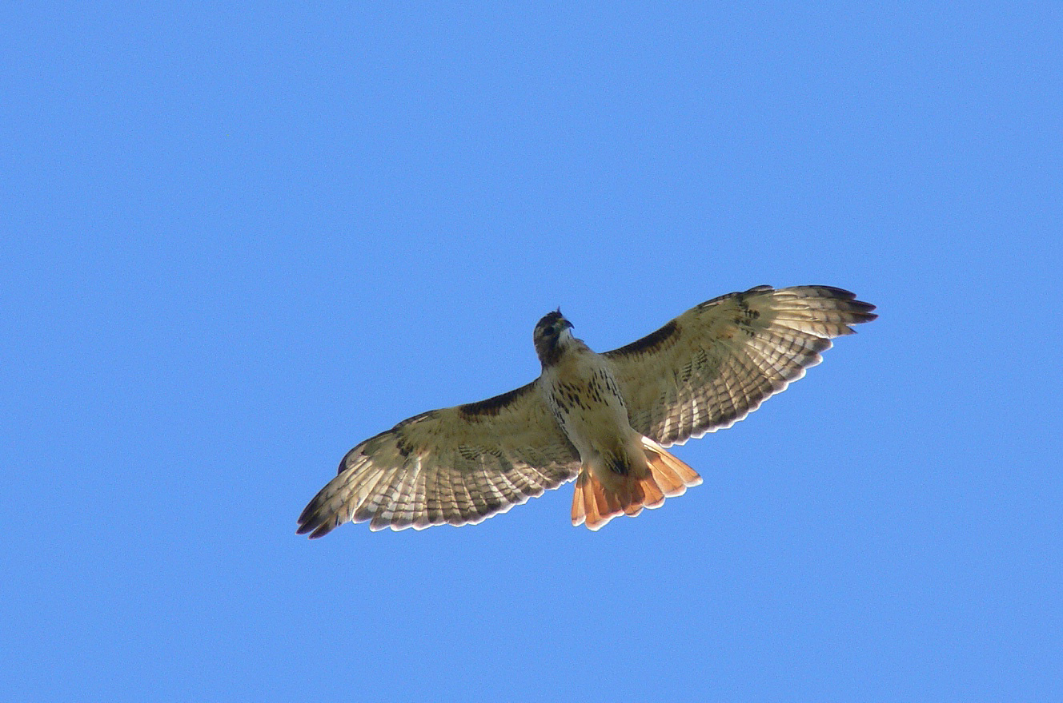
Stoddard Charitable Trust
Gardner Lions Club
Rutland Lions Association
Leominster Lions Club
Petersham Lions Club
Hubbardston Lions Club
Aubuchon Foundation
Westminster Lions Club
Barbara Palm
The Nordblom Family Foundation
The George F. and Sybil H. Fuller Foundation
Nypro Foundation
Fidelity Bank
DCR Recreational Trails Program
STIMSON
Memorial Foundation for the Blind
Alvarium Foundation

